**SMART GREEN BICYLE WITH PARKING SYSTEM USING IOT**

**1PRASHANT K, 2SACHIN K, 3VICKY**

1,2,3*Student,Department of Physics and Computer Science, Dayalbagh Education Institute*

**ABSTRACT**:

*In the todays’s scenerio air pollution is the major cause of global warming so that smart green cycle required and that also reduse theft for security purpose & parking problems for a human reliability .We have two areas and each area provide two parking slots .In this project has a GPS module with NodeMCU to show parking in a particular area and IR sensor indicates that parking slot is booked or not even book using (IOT web application) .By the use of website we can lock our cycle smartly so that smart green cycle provide a precious service in diifferent sectors.*

*And in the parking enter only registered cycles using RFID tags. So first the user I’d then they allowed*.

**KEYWORDS** : **NodeMCU, RFID sensor, Arduino uno, Solenoid motor, GSM module, Servo motor, Relay module, IR module.**

**INTRODUCTION**:

In the present time the technology is more and advanced in the world day by day , so we uses ola cabs technology to travel anywhere in local and long areas but many people can’t use this technology. But by using this project ,we can book bicycle easily through web application at the low cost for available. In this system we use a NodeMCU, and programs are developed in c.

**PROPOSED SYSTEM**:

In the proposed system uses a Infrared sensor with NodeMCU along with GSM module to provide a near parking location and NodeMCU sends the IR sensor data to the thingspeak to show parking. After that we can detect a bicycle slot is available or not for the user and allowed only those who registered ID ,RFID detect it.

In this this project we can also lock our cycle with the use of solenoid motor which connect with connect to NdeMCU control by phone through using web page.

**HARDWARE REQUIREMENTS**:

* NodeMCU
* IR sensor
* Arduino uno
* Servo motor
* RFID system
* Solenoid motor
* Relay module
* GSM module

**SOFTWARE REQUIREMENTS**:

* Arduino IDE
* Thingspeak

**ARCHITECTURE:**

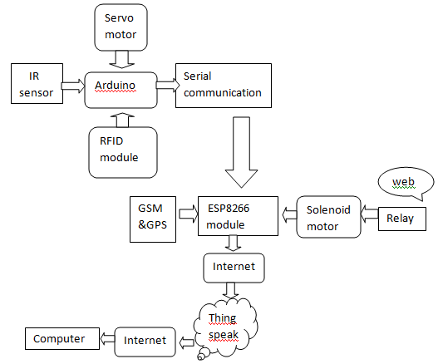

**FUTURE ENHANCEMENTS:**

* We can reduce a huge amount of pollution in our corporate area. Also we can contribute for Green *INDIA.*
* Any time we could find a new parking in our area using GPS system. We live in a healthy society.

**CONCLUSION:**

This idea is provide to develop our parking system intelligent .The parking for cycles will be monitor into various parameters and person to persons. It can be done by using various open source platforms or components – NodeMCU, Arduino uno ,IR sensor ,RFID system.

In future the functionality & usability at low cost,poor people and people around the world will continue to appreciate these system for benefits they bring. And it also improves the safety, effective development for less pollution.

**REFERENCES:**

1. Abhirup khanna ,Rishi anand “IOT based smart parking system ”university of Petroleum and Energy studies(UPES),January 2016.
2. Trio adino,syifaul fauda”IOT-Enabled door lock system”,school of Electrical Engineering and informatics ,Institute technology bandung,Indonesia .January 2019.
3. Pankaj verma “How to send data to cloud (Thingspeak) using ESP8266?”,march 2019.